Dayananda Sagar College of Engineering
Department of Electronics and Communication Engineering
Shavige Malleshwara Hills, Kumaraswamy Layout, Bengaluru – 560 078.
(An Autonomous Institute affiliated to VTU, Approved by AICTE & ISO 9001:2008 Certified)
Accredited by National Assessment and Accreditation Council (NAAC) with ‘A’ grade

OPEN ENDED EXPERIMENT

Course: ABNC-IV Laboratory (DIGITAL CIRCUIT DESIGN WITH FPGA- HDL LAB) | Semester : 4
Course Code: 22ECL471 | Date: 3-07-2024
Lab Batch: B3

A Report on
BOOTH MULTIPLIER

Submitted by

USN:1DS22EC113 | NAME:KUSHAL S
USN:1D222EC120 | NAME:MANISH S
USN :1DS22EC121  USN:1DS22EC124 | NAME:MANISHA S  NAME:MAURYA M

Faculty In-charge
DR SAPNA PJ
DR DEEPA NP

Signature of Faculty In-charge

INTRODUCTION:

Booth's multiplier is an efficient algorithm used in digital arithmetic for performing multiplication of binary
numbers. Named after Andrew D. Booth, who developed it in 1951, the algorithm reduces the number of addition operations required by encoding the multiplier in a way that handles strings of 1s efficiently. This is achieved through Booth's encoding, which represents the binary number in a signed digit form. The primary advantage of Booth's algorithm is its ability to speed up the multiplication process, especially for numbers with long sequences of 1s. It simplifies the hardware implementation by reducing the number of partial products, making it particularly useful in the design of arithmetic circuits in computer processors. Booth's multiplier is widely used in computer engineering and digital signal processing due to its efficiency and effectiveness in handling both positive and negative multipliers. The booth_multiplier module takes two 8-bit signed inputs (multiplicand and multiplier) and produces a 16-bit signed output (product). The multiplication process is done using Booth's algorithm, which involves adding or subtracting the multiplicand from the accumulator (A) based on the least significant bit of the multiplier (Q[0]) and a previous least significant bit (Q_1). The result is then shifted right, and the process is repeated for the number of bits in the multiplier.

BLOCK DIAGRAM:

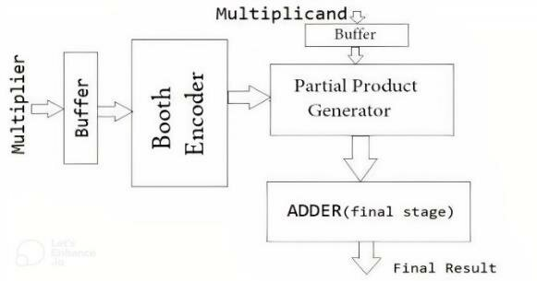

RTL CODE:

module booth_multiplier (
input signed [7:0] multiplicand,
input signed [7:0] multiplier,
output reg signed [15:0] product
);
reg signed [15:0] A, Q, M;
reg Q_1;
reg [3:0] count;

always @(multiplicand, multiplier) begin
// Initialize variables
A = 16'b0;
M = multiplicand;
Q = {8'b0, multiplier};
Q_1 = 1'b0;
count = 8;

// Booth's algorithm
while (count > 0) begin
case ({Q[0], Q_1})
2'b01: A = A + M;
2'b10: A = A - M;
endcase

// Arithmetic right shift
{A, Q, Q_1} = {A[15], A, Q[15:1]};
count = count - 1;
end

product = {A, Q[7:0]};
end
endmodule

TESTBENCH CODE:

module testbench;
reg signed [7:0] multiplicand;
reg signed [7:0] multiplier;
wire signed [15:0] product;

booth_multiplier bm (
.multiplicand(multiplicand),
.multiplier(multiplier),
.product(product)
);

initial begin
// Test cases
multiplicand = 8'b00000101; // 5
multiplier = 8'b00000011; /

SIMULATION RESULTS :

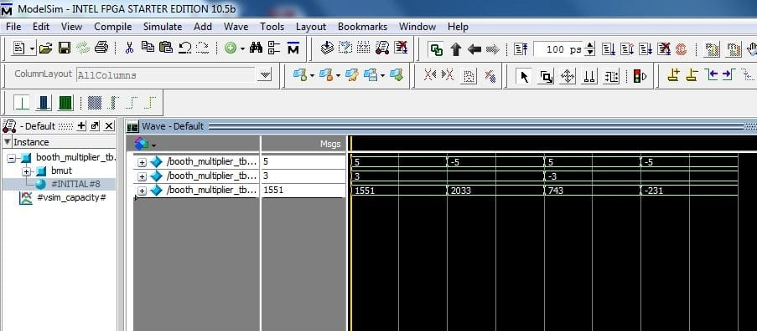

RESULT DISCUSSION:

Discussing the results of implementing a Booth multiplier involves examining several key aspects:

Reduction in Operations:
Booth's algorithm minimizes the number of necessary operations by encoding groups of binary digits. This results in fewer add/subtract operations compared to traditional multiplication methods.
This reduction is particularly notable when dealing with binary numbers that have large blocks of consecutive 0s or 1s.
Performance:
The Booth multiplier typically demonstrates improved performance in terms of speed and efficiency.
Hardware implementations of Booth's algorithm show faster multiplication times due to the reduced number of arithmetic operations.
Hardware Complexity:
While Booth's algorithm reduces the number of operations, it introduces some complexity in terms of control logic for handling the encoding and decoding of digit pairs.
which is critical in power-sensitive applications like mobile devices and embedded systems Handling of Signed Numbers:
Booth's algorithm effectively handles both positive and negative binary numbers, making it versatile for a wide range of applications.
The two's complement representation of signed numbers is seamlessly integrated into Booth's algorithm, ensuring accurate results.
Area and Power Consumption:
The reduction in arithmetic operations generally leads to a smaller area footprint in hardware implementations.
This can also translate to lower power consumption.

CONCLUSION:
The conclusion of a Booth multiplier implementation highlights its significance in efficient digital multiplication, particularly in computing systems that require speed and resource optimization. Booth's algorithm, by recoding the binary multiplication process, reduces the number of partial products generated, thereby decreasing the overall computational steps. This efficiency stems from the ability of the algorithm to handle both positive and negative multipliers uniformly, leveraging bitwise operations to streamline the process. Consequently, Booth multipliers are advantageous in applications demanding high performance, such as digital signal processing and computer graphics. Additionally, the algorithm's adaptability to various word sizes makes it versatile for different computing environments. Despite its complexity in terms of initial learning and implementation, the long-term benefits in processing speed and resource efficiency are substantial. Thus, Booth's algorithm remains a crucial tool in the repertoire of digital arithmetic operations, contributing to the advancement of computational technology.

